International Conference
Contemporary Turkish Studies at a Glance II:
Turkey Transformed? Power, History, Culture
Date: October 18-19, 2014
Venue: Istanbul Bilgi University, Santral Campus
Turkey has undergone substantial social, economic, and political transformations over the last decades. Political reforms have reshuffled power relations between institutions, actors, and elites; economic development has benefited broad segments of society across the country; and, until recently, Turkey convincingly presented itself as a key actor in the region.
Yet, authoritarianism, corruption, and growing societal polarization recall some of the darker moments in the country’s troubled history. At the same time, these developments have sparked a social counter-movement, which cuts across ideological, social, religious, and cultural divisions. The movement, which became most visible during the Gezi protests, illustrated the capacities of a pluralistic civil society and offered a snapshot of the potentialities of inclusive forms of social organizations in Turkey.
Recent political developments have raised the question to what extent the last decades have witnessed a real transformation of the power structures that shape Turkish society. Has the country’s political culture moved beyond modes of hierarchical engagement between the state and its citizens? Are we witnessing the rise of new forms of state action or a return to 20th century authoritarianism? In this context, the transformative impact and lasting power of the Gezi movement must be critically assessed.

Outline
The two-day conference will provide an opportunity for young scholars focusing on issues related to Turkey to present their papers to some of the most renowned academics and institutions in the field. They will have the chance to position themselves in the international research community and to debate related topics and research questions in an interdisciplinary environment. The event will be framed by a panel discussion and keynote speeches by some of the most prestigious scholars in the field. Furthermore, eight panels will focus on central issues and research questions for the studies of contemporary Turkey. Each panel will include three presentations and a discussion moderated by the panel chair.
The topics, framing the presentations and the discussions of the panels have detailed in the Call for Papers. Each day will finish with a roundtable discussion highlighting the outcome of the panels by the chairs and the implications for Turkish Studies as an interdisciplinary and applied area of study. Additionally, while the conference is underway, organizations, journals and other actors engaged with Turkish Studies will set-up stands to exhibit their work and publications.

Supported by
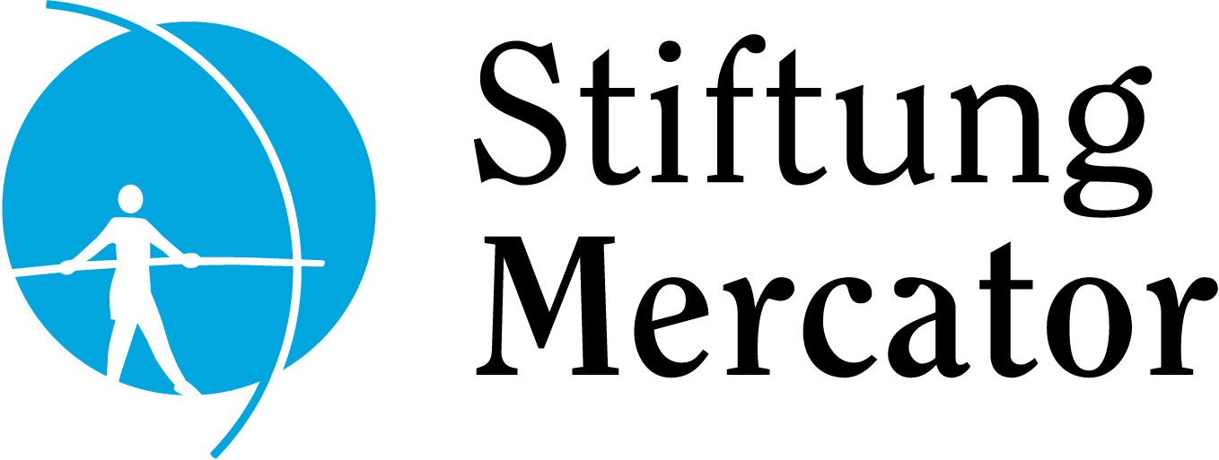

Program
October 18, 2014

09:30 - 10:00 Registration

10:00 - 10:30 Welcoming Remarks
Remzi Sanver - Rector of Istanbul Bilgi University, tbc
Ayhan Kaya - Istanbul Bilgi University
Daniel Grütjen - Network Turkey
Esra Özyürek - London School of Economics
Fuat Keyman - Istanbul Policy Center
Michael Schwarz - Stiftung Mercator, tbc

10:30 - 11:15 Panel: Gezi and Beyond
Fuat Keyman - Istanbul Policy Center
Nilüfer Göle - Ecole des Hautes Etudes en Sciences Sociales
Craig Calhoun - London School of Economics
Moderator: Elise Massicard -

11:30 - 13:00 Session I

Panel I  Turkey and its Neighbors  Birce Altıok - Koç University  Sinan Karşıyaka - Istanbul Bilgi University  Re-calibrating the Turkish Foreign Policy after the Arab Spring: From Pro-activism to Uncertainty by Easing off Ideational and Liberal Goals  Jean-Baptiste Le Moulec - Institut Français d’Etudes Anatoliennes  A Turkish Epistemic Community: Sociology of a Foreign Policy Brainstorming  Magdanela Kirchner - German Council on Foreign Relations  Şafak Baş  Chaldiran 2.0: Conceptualizing Iranian-Turkish Relations after the Arab Spring  Chair  Senem Aydın Düzgit - Istanbul Bilgi University | Panel II  Democratization and Institutional  Reform  Nicolas Monceau - University of Bordeaux  State and Religion: the Evolution of Secularism in Turkey  Official ideology, Political Polarization and Social Perceptions  Ceren Lord - London School of Economics  ‘Path-dependent Path-shaping’; Situating Change under the AKP  Kerem Yıldırım - Koç University  Clientelistic Linkages and the Turkish Democracy  Ebru İlhan - Eczacıbaşı Group  Plugged Out: AKP's Mishandling of Turkey's Economic, Political and Social Adaptation to the Digital Era  Chair  Fuat Keyman - Istanbul Policy Center

13:00 - 14:30 Lunch Break

14:30 - 16:00 Session II

Panel III  Public Space and Contestation  Azat Zana Gündoğan - University of Michigan, tbc  Divergent Forms of Contestation against Urban Transformation Projects in the Istanbul City-region: The Role of Ethnicity and Political Memory in Grassroots Mobilization  Deniz Yonucu - Boğaziçi University  From Center to Margin: Rethinking the Gezi Uprisings with Istanbul’s Alevi Neigborhoods  Zerrin Özlem Biner - University of Cambridge, tbc  What is Hidden beneath the Wall Surrounding the Mor Gabriel Monastery? Consolidating Borders between Self and Other, Self and the State  Chair  Ayfer Bartu Candan - Boğaziçi Üniversity | Panel IV  Diasporas and Transnationalism  Kristen Biehl - University of Oxford  Contested Homes: Social and Spatial Encounters with Difference in a Migrant Hub of Istanbul  John McManus - University of Oxford  Exploring Virtual Diasporic Space: Examples from European Beşiktaş Fans  Aylin Yıldırım Tschoepe - Harvard University  Locating the German Turks: Transnational Return Migration and Constructions of Culture, Identity and Space  Gerda Heck - University of Göttingen  Worshipping in the Hotel Golden Age  Chair  Ayhan Kaya - Istanbul Bilgi University

16:00 - 16:30 Coffee Break

16:30 - 17:30 Concluding Panel
Senem Aydın Düzgit- Istanbul Bilgi University
Ayfer Bartu Candan - Boğaziçi Üniversity
Ayhan Kaya - Istanbul Bilgi University
Fuat Keyman - Istanbul Policy Center

Chair: Pınar Uyan - Istanbul Bilgi University

October 19, 2014

9:30 - 10:30 Keynote Speech
Cihan Ziya Tuğal - University of California, Berkeley

10:45 - 12:15 Session III

Panel V  Historical Perspectives  Christiane Czygan – University of Hamburg  The Ruler and the People: Shifting Paradigms in Ottoman Ruler Poetry from the 15th to the 19th century  Sara-Marie Demiriz - University of Münster  Pledging Allegiance to the Nation: Celebrations of the Nation in Atatürk’s Turkey  Erol Ülker - Istanbul Kemerburgaz University  Turkish National Movement, Mass Mobilization, and Demographic Change in Istanbul, 1922-1923  Chair  Suraiya Faroqhi - Istanbul Bilgi University | Panel VI  Political Economy  Tim Dorlach - Koç University  Social Neoliberalism in Comparative Perspective: Changing Patterns of Inequality during the AKP Era  Lisa Ahsen Sezer – London School of Economics  The Political Economy of Business Associations in Turkey: Social Movement Tactics, Social Networks, and Regional Development  Meltem Yılmaz Şener – Istanbul Bilgi University  AKP’s Implementation of a Risk Management Project of  Project of the World Bank: Creating Entrepreneurial or Charity Dependent Poor People?  Gül Berna Özcan - Royal Holloway University of London  Umut Gündüz - Istanbul Technical University  Changing Business-Politics Connections Under Political Islam: The Case of Energy Privatisations  Chair  Çağlar Keyder - Boğaziçi Üniversity

12:15 - 13:30 Lunch Break

13:30 - 14: 30 Keynote Speech
Nils Muižnieks, Council of Europe Commissioner for Human Rights

14:45 - 16:15 Session IV

Panel VII: Rule of Law  Elif Gözler - University of Exeter  Turkey’s New Constitution Making Attempt and the Participation of Minority Organizations during the Public Consultation Process  Ayşegül Kars Kaynar - Middle East Technical University, tbc  Political Trials and Second Jurisdiction of the State: Normalcy of the Exception  Mine Yıldırım - Norwegian Helsinki Committee  The ECtHR- An Effective Agent of Domestic Change in the Context of the Protection of Freedom of Religion or Belief in Turkey?  Chair  Kerem Altıparmak - Ankara University | Panel VIII: Identities and Transgressions: Religion, Ethnicity, Sexuality  Chiara Maritato - University of Turin  Reassessing Turkish Social Assistance in the Light of Religious Female Engagement: Female Preachers (vaizeler) between Spiritual and Social Support  Hikmet Kocamaner - Brandeis University  Governing the Family through Religion in Contemporary Turkey: Secularism, Presidency of Religious Aﬀairs, and Family Guidance and Counseling Offices  Esin Düzel - University of California  Getting Beautiful in Diyarbakır: Changing Moral and Political Landscapes in Post-Conflict Kurdish Culture  Bülent Bilmez - Istanbul Bilgi University  Coming to Terms with the Future: Collective Memory Politics on Dersim Massacre (1937-38) and (un)willingness to Confront the Religious and Ethnic Complexity in Turkey  Chair  Esra Özyürek - London School of Economics

16:15 - 16:45 Coffee Break

16:45 - 17:45 Concluding Panel
Kerem Altıparmak - Ankara University
Suraiya Faroqhi - Istanbul Bilgi University
Çağlar Keyder - Boğaziçi Üniversity
Esra Özyürek - London School of Economics
Chair: Kerem Öktem - University of Graz

17:45 - 18:00 Closing Remarks
Meltem Ersoy - Network Turkey
Ayhan Kaya - Istanbul Bilgi University

